Conclusion

Conclusion
The distribution of wind in Egypt varies from location to another and the wind is restricted to some locations pointed along on the red sea.
That’s why our wind turbine named as the wind cube located inside urban cities instead of remote sites.
From our studies of fluid dynamics science we noticed that nozzle increases the velocity of fluid by a double and decreases the pressure.
From this theory we built up our project as we overcome the ordinary problem of low wind speed facing us in urban cities and to be able to get wind power from these locations known as a poorly wind speed sites.
And from now on this project can be constructed on any building surface, offering us a green energy producing electricity which reduce the consumption of electricity we are using and of course the electric bill will be reduced.
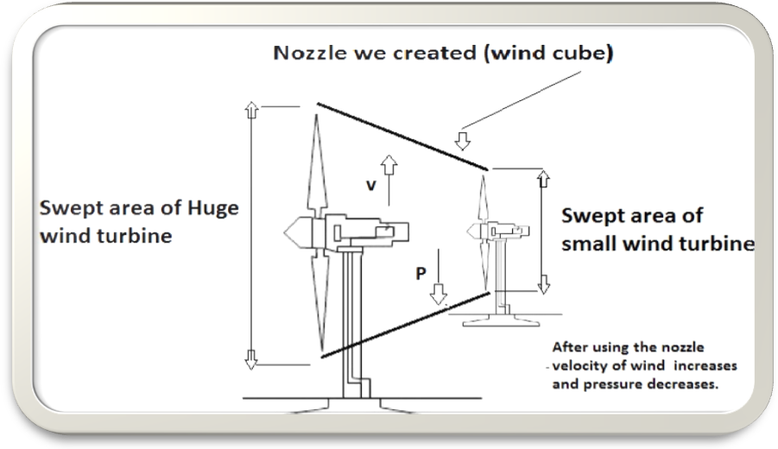
We were able to prove the theory that a wind cube with a small rotor and a small swept area can produce the same power of a big wind turbine with huge swept area can produce.

